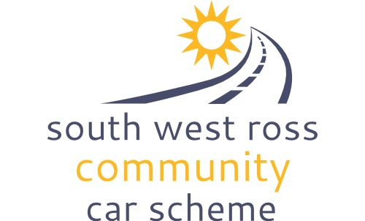
Volunteer Telephonist Information

Thinking of becoming a telephonist for SWRCCS?
- Telephonists need to have access to a telephone and it is useful to have access to a computer as daily onwards and driver lists are sent out by email – but this is not essential
- Because of the nature of the work you will be doing with us, you must also be able to provide character references.
- A reasonable knowledge of the geography of the area is helpful
- Being good at administration and organisation will help keep a track of car runs, drivers and details
- Being a good listener helps when talking through what is needed for a journey etc

Our passengers
Our passengers come from a broad cross section of the community and use SWRCCS for a wide variety of reasons. As well as a core of regular passengers, we get several “one off” requests – for instance, when people are temporarily without transport. Some of our passengers may be quite isolated and so like having a chat.

Bookings
Normal bookings are usually within the local area and are made by our volunteer telephonists - you will contact the driver to ask if they are available to do a run. You will tell the driver who the passenger is, when they wish to travel, the pick-up point and destination. The driver will then say if you are able to do the run. If they are unable or do not wish to do that particular run for whatever reason, they can just simply say, “Sorry, no” – they are not obliged to explain why! Furthermore, Drivers have the right to refuse to transport any passenger who is drunk or abusive when they arrive to collect them.
Hospital runs are longer runs and are usually booked through the Coordinator.

User Calls
Sometimes telephonist are asked to give users a call to see if they are OK. A sample script will be given to you so you know what type of things to ask.

Rota
A rota will come out every couple of months and you are asked when you are available or if there are days when you are usually unavailable. You choose how many shifts you do and instructions are given as to how to transfer the line to your phone. You are also given an ‘Onwards’ – which is a list of car runs that have already been organised or has highlights of the runs you are being asked to organise. You will also be given a driver list with phone numbers of drivers and what type of runs they are willing to do.
Phone charges for outgoing calls appear on your phone bill. A per diem of £5 can be claimed to cover any additional costs incurred while on telephone duty.

All Above Board!
We will ask you to complete a Code of Conduct which we ask of all our volunteers. As SWRCCS does not have to do PVG checks, we also ask for references from two "responsible persons" saying that they recommend you as a telephonist for the scheme. We will need to contact your referees by email or phone to ask them to supply written references. (You may wish to check that they will be happy about this before providing us with their names.)

Apply now!
An application form is attached. Please complete the application form and then, along with photocopies of the relevant documentation, send to the coordinator, in the S.A.E. provided.
Please feel free to call our coordinator on the number below if you have any questions you would like to ask or would like more details or a look at our policies.
Or if you are passing you would be very welcome to drop into the office (core hours Tues – Thurs 11:00 to 15:00)

Thank you

Once you have returned your application form, etc and we have contacted your referees, we will confirm your acceptance and send the Volunteer Manual

