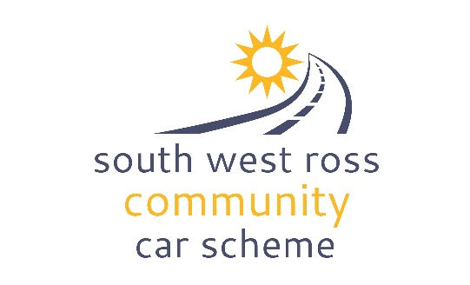
COMMUNITY CAR
BOOKING ENQUIRY FORM

Instructions
Please complete this form and send back fully completed to coordinator@swrc-carscheme.co.uk to enquire about a booking for the community car.

We will complete DVLA checks and check our reservation diary and get back in touch with you regarding availability and whether or not we can proceed with the booking as well as pick up instructions. Please give at least 5 days notice.

Date of Journey
Collection Time |  | Return Time
Estimated Mileage |  | Destination
Pick up Location (please highlight) | Shieldaig | Number of passengers in addition to driver max 6 (Shieldaig)
Purpose of the journey
Wheelchair facility required | Yes / No  NOTE: If yes instruction will be needed for the use of the lift.

SWRCCS Volunteer requested | Yes / No
Group or Passenger Name
Your details |  | Driver details ESSENTIAL INFO
Full name
Address
(incl postcode)
Contact telephone number
E-mail address
Driving License Number | n/a
NI Number | n/a

Terms and conditions of vehicle use:
- The person/group booking the vehicle will then be invoiced at the rate of 30p per mile.(There will be a minimum charge of £10 and a maximum charge of £50). *
- All passengers are expected to contribute towards the cost of the vehicle unless under 16 or in receipt of income support. Fares collected should be declared to SWRCCS and used towards the cost of hire (detailed above).
- Payment will be due no later than 14 days from the invoice date
- Use of the vehicle is dependent on the following conditions being met:
- Drivers must be over the age of 25 and have held a UK license for a minimum of two years
- All drivers are checked on DVLA website through the Highland Council (to do this we need driving license number and NI number and postcode. SWRCCS will do this on your behalf and will agree to DVLA Privacy policy on your behalf – details can be found https://www.gov.uk/government/publications/dvla-privacy-policy/dvla-privacy-policy
- All users agree to operate the vehicle according to legal requirements
- All users agree to conduct themselves appropriately and understand that during the hire, the way they behave on the road reflects the South West Ross Community Car Scheme, as well as their own group/organisation.
- The vehicle is to be returned clean and tidy. Failure to do so may result in an additional
cleaning fee.
The vehicle is to be returned with a full tank of fuel. Any fuel cost involved can be claimed from SWRCCS with submission of a receipt.

* These charges will be regularly reviewed.

Declaration

I consent to SWRCCS processing and holding the above data for the purposes stated. I declare that the information I have provided on this form is accurate and truthful and will abide by all the terms and conditions stated.

Signature

Name

Date

