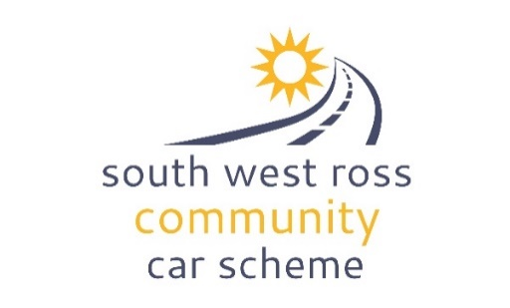
SWRCCS COMMUNITY CAR

CHECKS FORM SHIELDAIG/TORRIDON

The vehicle should be filled up with fuel on your return journey. You will be re-imbursed for any costs with the submission of a receipt.
Please take care to complete all the checks before you set off and when you drop the car off. PLEASE NOTE: your driving is being monitored

Name: Date:
PLEASE ALWAYS COMPLETE:
No of Passengers:

Fares collected:
Miles with passengers:
Terms and conditions for use of the SWRCCS vehicle
- I am not under the influence of drugs/alcohol
- I will abide by the laws of the road
- I will drive with consideration for others
Before departure walk around the car and then complete the form below as

Exterior checks before departure when dropping off
Windscreen and wiper blades Visual check of tyres
Any damage to bodywork?

Interior checks
Driving seat is adjusted appropriately Mirrors are adjusted correctly
I am familiar with the dashboard controls Wipers and washers are working properly
Fuel Level
I have read the instructions for the fuel card
Mileage
No warning lights on the dashboard
I am aware of the location of the passenger box
Trained in the use of the wheelchair equipment (If appropriate)

Make sure the car is parked in the appropriate place and is locked before returning the key to the key box located by the door of the Loch Torridon Community Centre / Fence Post at the entrance to Shieldaig Free Church car park
Signature: Date:

For SWRCCS drivers only - please complete the back of this form

For SWRCCS volunteer drivers only

Please record your passenger miles and driver only miles for the journey that was made with this vehicle (any miles done in your own vehicle please use the monthly Expenses Claim Form).
Purpose of the journey:
Payment received: ___________________________________________
(Please leave any payment in the car with this form)
Passenger name(s): Number of deliveries (If relevant):
Please do not include these miles on your personal monthly claim form but do claim the miles in your own vehicle to and from the SWRCCS Community Car.
If you have any additional claim(s) for lunch/refreshment (up to £15) please include, together with the receipt/s (or photos) to the coordinator with your monthly claim form.

Thanks

