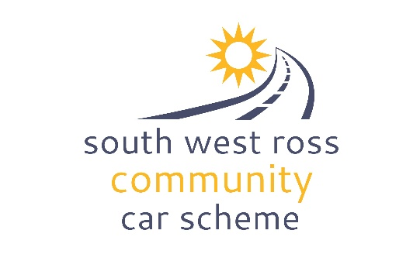**COMMUNITY CAR**

**BOOKING ENQUIRY FORM**

|  |
| --- |
| **Instructions** |
| *Please complete this form and send back fully completed to* [*coordinator@swrc-carscheme.co.uk*](mailto:coordinator@swrc-carscheme.co.uk) *to enquire about a booking for the community car.*  We will check our reservation diary and get back in touch with you regarding availability and whether or not we can proceed with the booking as well as pick up instructions. Please give at least 5 days notice. |

|  |  |  |  |
| --- | --- | --- | --- |
| **Date of Journey** |  | | |
| **Collection Time** |  | **Return Time** |  |
| **Estimated Mileage** |  | **Destination** |  |
| **SWRCCS Volunteer Driver requested** | **Yes / No** | **Number of passengers in addition to driver (max 8)** |  |
| **Purpose of the journey** |  | | |
| **Wheelchair facility required** | **NOTE: NOT CURRENTLY AVAILABLE Yes / No**  ***NOTE: If yes instruction will be needed for the use of the lift.*** | | |

|  |  |  |
| --- | --- | --- |
| **SWRCCS Volunteer requested** | **Yes / No** | |
| **Group or Passenger Name** |  | |
| **Your details** | | **Driver details (if different)** |
| **Full name** |  |  |
| **Address** |  |  |
| **Contact telephone number** |  |  |
| **E-mail address** |  |  |

|  |
| --- |
| **Terms and conditions of vehicle use:** |
| * The person/group booking the vehicle will then be invoiced at the rate of 30p per mile.(There will be a minimum charge of £10 and a maximum charge of £50). * * All passengers are expected to contribute towards the cost of the vehicle unless under 16 or in receipt of income support. Fares collected should be declared to SWRCCS and used towards the cost of hire (detailed above). * Payment will be due no later than 14 days from the invoice date * Use of the vehicle is dependent on the following conditions being met: * Drivers must be over the age of 25 and have held a UK license for a minimum of two years * All users agree to operate the vehicle according to legal requirements * All users agree to conduct themselves appropriately and understand that during the hire, the way they behave on the road reflects the South West Ross Community Car Scheme, as well as their own group/organisation. * The vehicle is to be returned clean and tidy. Failure to do so may result in an additional   cleaning fee.  The vehicle is to be returned with a full tank of fuel. Any fuel cost involved can be claimed from SWRCCS with submission of a receipt.  * These charges will be regularly reviewed. |

|  |
| --- |
| **Declaration** |

**I consent to SWRCCS processing and holding the above data for the purposes stated. I declare that the information I have provided on this form is accurate and truthful and will abide by all the terms and conditions stated.**

**Signature**

**Name**

**Date**