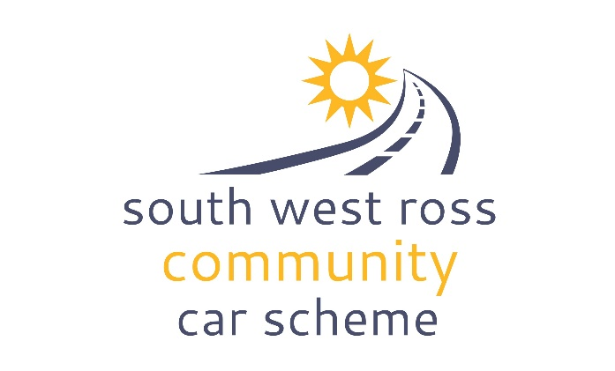
ADVERSE WEATHER
POLICY AND
CANCELLATION
PROCEDURES

PURPOSE
This policy has been developed to identify relevant procedures to be applied in the event of severe or adverse weather conditions, that may prevent volunteer drivers fulfilling any previously agreed booking with a service user.

Adverse weather conditions may include:-
- heavy snowfall
- flooding
- thick fog
- poor road conditions due to ice, spillages etc.

AIM
The aim of this policy is to empower volunteers and users to make sensible decisions regarding the safet y of any particular journey they have been asked to do on behalf of SWRCCS.

In the event of severe weather the volunteer driver, SWRCCS or the passenger can decide to cancel the journey.

EFFECT ON VOLUNTEERS
When volunteer drivers themselves consider it is too dangerous to travel due to adverse weather conditions, they are required to contact the service user and the Coordinator as soon as possible. No volunteer is obliged or required to travel if they or SWRCCS consider it too dangerous or unsafe to do so.

IF IN DOUBT JOURNEYS CAN ALWAYS BE RE-ARRANGED
The safety of you and your passenger always comes first

EFFECT ON USERS
When passengers decide to cancel they are asked to give as much notice as possible. Ideally 12-24 hours notice is requested regarding cancellation of your journey booking but the very minimum time for cancelling a booking is 2 hours’ prior to the originally agreed pick up time. Passengers are asked to contact the volunteer driver directly and the Coordinator.

EFFECT ON STAFF
If SWRCCS make a decision to cancel journeys due to severe weather in order to keep both passengers and drivers safe, all drivers and all passengers, who have booked journeys will be contacted to inform them of the decision. This will only be made if severe weather warnings affecting the area covered by the car scheme have been issued by the Met office. Once the decision to resume the service has been made, SWRCCS will contact all passengers and drivers as required.

The Coordinator receives alerts from the Met office and will endeavour to share these when received with volunteer drivers who have journeys booked for the time affected.

EFFECT ON TRUSTEES
To periodically review this policy to consider its appropriateness and how it is being implemented.

Document version control

Version number | Change or update | Author or owner | Date | Date Approved by Board
1.0 | First version | PF | 23/01/2020 | 23/01/2020
2.0 | Updated to template | PF | 02/09/2024 | 18/02/2025

