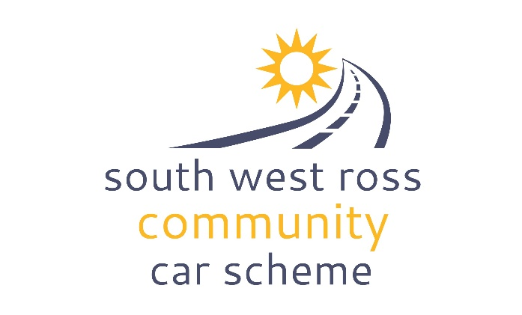
DATA PROTECTION
POLICY

PRIVACY STATEMENT
The South West Ross Community Car Scheme takes the privacy of all its members, volunteers, users, staff and trustees very seriously. We will only collect and keep personal data as necessary in order to carry out our purpose of providing transport within the community of South West Ross.
We will protect all personal data according to the rules of the Data Protection Act 2018 (UK GDPR) and the General Data Protection Regulation (GDPR), as laid out in our Data Protection Policy (here). Personal data will only be retained for as long as it is needed for SWRCCS to carry out its purpose and to meet legal requirements. It will then be securely destroyed, according to our Data Retention Policy.
PURPOSE
This policy applies to all trustees, employees, volunteers, users and members of SWRCCS and covers our commitment to meeting our requirements to protect personal data under the Data Protection Act 2018 (also known as the UK GDPR) and the General Data Protection Regulation (GDPR).
“Personal data” means any information relating to an identified or identifiable individual.
AIM
The aim of this policy is to ensure that all personal data held by SWRCCS will be:
- processed lawfully, fairly and in a transparent manner;
- collected for specified, explicit and legitimate purposes and not further processed in a manner that is incompatible with those purposes
- adequate, relevant and limited to what is necessary
- accurate and kept up to date
- kept in a form which permits identification of data subjects for no longer than is necessary
- processed in a manner that ensures appropriate security of the personal data, including protection against accidental or unauthorised access to, or destruction, loss, use, modification, or disclosure of personal data (integrity and confidentiality).
EFFECT ON VOLUNTEERS & MEMBERS
Undertaking Volunteer Duties
In order to undertake the duties of a volunteer driver or a volunteer telephonist, volunteers have access to personal data of other volunteers and users of SWRCCS. It is therefore essential that volunteers are aware of the sensitivity of having access to such personal data and acknowledge the trusted position they are in. As part of our Data Protection Policy all volunteers sign up to a Code of Conduct that contains the following statement in relation to data protection.
Uphold confidentiality by;
keeping personal and confidential information about passengers, volunteers and other people connected to SWRCCS to oneself. This is particularly important when phone numbers or information about health conditions are shared.
Signing up as a Volunteer or Member
As part of the application form, all volunteers and members sign up to the following clause:
DATA PROTECTION ACT 1998 (the Act) - The information you have supplied will be used for the purpose for which you have provided it and any relevant procedures following from this. This data will be maintained in accordance with the Act and will not be passed on or sold to any other organisation without your prior approval unless this is a legal requirement.
I agree / do not agree to the information I have given being held on the South West Ross Community Car Scheme’s computer database. (Please delete as applicable)
I wish to become a member of SWRCCS and will abide by its constitution, policies and procedures.
I agree to inform SWRCCS of any changes to the above information.
EFFECT ON USERS
In order to access car runs delivered by SWRCCS, users of the scheme give the organisation their telephone numbers and addresses. These are shared with volunteer drivers and telephonists so that the runs can be fulfilled and the user also receives the volunteer driver’s telephone number in case they need to change the details of the run at a late stage. All users are expected to use this personal information for its intended purpose only and if there is a repeated breach of such trust, they can be excluded from future runs requested by them.
EFFECT ON TRUSTEES
As part of the application, all trustees sign the following statement as part of data protection:

I understand and agree that the personal information I have provided OSCR in this form may be used for the purposes listed above in line with the Data Protection Policy.

EFFECT ON STAFF
As part of the job application, all staff sign the following statement as part of data protection:
Privacy statement
We will only use the information you supply to us on this form to process your application and to produce anonymized recruitment statistics. Personal information about unsuccessful candidates will be held for six months after the recruitment exercise has been completed and then destroyed.
If you are successful in your application to work for SWRCCS:
Following our job offer we will contact your employment references using the details you provide on this application form. We will compile a file relating to your employment. The information contained in this will be kept secure and will only be used for purposes directly relevant to your employment. Once your employment with SWRCCS has ended, we will retain the file in accordance with the requirements of our appropriate policy and then delete it.

EFFECT ON ORGANISATION
Lawful, fair and transparency
SWRCCS shall keep and maintain a Record Retention Schedule (contained within the Data Retention Policy) to record where and why we process personal data. The Record Retention Schedule will be kept up to date and fully reviewed every 2 years.
The way in which we process personal data is detailed within this policy. Our Data Protection Policy will be reviewed every two years.
Purpose limitation
We will not use the personal data for any other purpose other than that intended unless we get consent, or we have a clear obligation or function set out in law.
Data minimisation
We will make sure that the personal data we are processing is:
- adequate – sufficient to properly fulfil our stated purpose;
- relevant – has a rational link to that purpose; and
- limited to what is necessary – we do not hold more than we need for that purpose.
Data accuracy
SWRCCS will take all reasonable steps to ensure the personal data we hold is correct and up to date.
Storage limitation
SWRCCS will not keep personal data for longer than needed, as detailed in our Data Retention Policy. This records how long we keep personal data for and how it will be erased or removed from our systems.
Integrity and confidentiality
SWRCCS takes the security of personal data extremely seriously. Our security measures are regularly reviewed to make sure that we keep personal data secure and confidential.

EFFECT ON ALL
Rights of individuals
Individuals have the right to access their personal data and any such requests made to SWRCCS shall be dealt with in line with legal requirements, with some limited exceptions.
The UK GDPR provides the following rights for individuals in relation to their personal data:
- the right to be informed – we do this by making sure our Privacy Statement and associated policies are correct and up to date and direct individuals to these notices on our website (https://www.swrc-carscheme.co.uk)
- the right to access their own data – any subject access requests must be notified to the Coordinator search all of our systems before responding to the individual within 30 days, as required by law.
- rectification – we will quickly update any personal data which has been identified as inaccurate or incorrect.
- erasure – we will remove any personal data if an individual requests this, unless we have another lawful basis which would prevent this, e.g. we cannot delete employee records as we need to keep these to comply with other legislation.
- to restrict processing - where there is a dispute about the accuracy, validity or legality of personal data held by us, an individual has the right to require us to cease processing the data for a reasonable period of time to allow the dispute to be resolved.
- the right to data portability - we will provide an individual with their data in a common and machine-readable electronic format.
- the right to object – complaints or objections to processing personal data will be dealt with quickly and accurately as detailed in SWRCCS Raising a Concern procedure.
Data breach
A personal data breach means a breach of security leading to the accidental or unlawful destruction, loss, alteration, unauthorised disclosure of, or access to, personal data.
Where there is a high risk to individuals’ rights and freedoms, we will inform those individuals without undue delay. The Coordinator will keep a record of all personal data breaches through an incident report form.
OTHER DOCUMENTS REFERENCED
Data Retention Policy (including Record Retention Schedule)
Will be posted on website

Code of Conduct
https://www.swrc-carscheme.co.uk/privacy

Volunteer Driver Application Form
https://www.swrc-carscheme.co.uk/_files/ugd/678050_41b610db4a9d4bacad2c98bb57ddb669.pdf

Volunteer telephonist Application Form
https://www.swrc-carscheme.co.uk/_files/ugd/678050_5fd21e70f079405d8fbee0fd39bbc096.pdf

SWRCCS Job Application form
Available from SWRCCS Office

Trustee Application Form
Available from SWRCCS Office

Raising a Concern Procedure
https://www.swrc-carscheme.co.uk/privacy
Document version control
Version number | Change or update | Author or owner | Date | Date Approved by Board
1.0 | First version | MP/PF | 24/10/2024 | 18/02/2025

