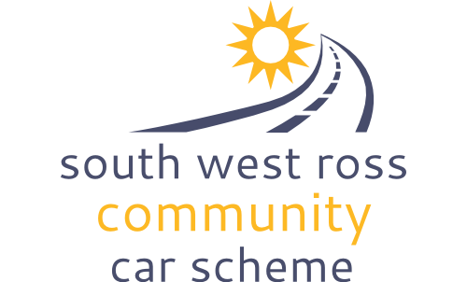
SOUTH WEST ROSS COMMUNITY CAR SCHEME

CODE OF CONDUCT

Introduction
In keeping with its vision and values, SWRCCS is committed to maintaining the highest degree of ethical conduct amongst all its staff, volunteers and associated personnel. To help increase understanding, this Code of Conduct details SWRCCS’s expectations of everyone involved in its activities. The Code is applicable at all times and breaches are grounds for further investigation and possible follow up.

Mission and values
The following paragraphs are taken from the Memorandum and Articles of Association
The object of the Company is to provide a community transport service for such of the inhabitants of South West Ross and its neighbourhood who are in need of such a service because of age, sickness or disability (mental or physical), or poverty, or because of a lack of availability of adequate and safe public passenger services.
In carrying out its objects, the Company shall seek to ensure equality of opportunity for all sections of the community in its own affairs and in society generally.

Code of Conduct Standards
While undertaking activities on behalf of SWRCCS everyone is expected to;-

Uphold the integrity and reputation of SWRCCS , ensuring that conduct is consistent with SWRCCS’s values and standards by;
- treating all people fairly with respect and dignity
- observing all laws
- ensuring that actions do not bring SWRCCS into disrepute
- not working under the influence of alcohol or drugs
- adhering to all SWRCCS policies and procedures
- behaving in a manner which avoids any unnecessary risk to the safety, health and welfare of oneself and others, including passengers, recipients of deliveries and other members of the community
- declaring any potential conflict of interest with the work of SWRCCS to the board of trustees

Uphold confidentiality by;
- keeping personal and confidential information about passengers, volunteers and other people connected to SWRCCS to oneself. This is particularly important when phone numbers or information about health conditions are shared.

Ensure that all our passengers and users of the scheme are safeguarded by;
- not physically assaulting a child or vulnerable adult
- not emotionally or psychologically abusing a child or vulnerable adult
- reporting if any action is witnessed that shows any form of abuse to a child or vulnerable adult while a passenger, to the coordinator or, if preferred, a member of the board of trustees

Complaints and reports
Everyone connected to SWRCCS should bring to the attention of the coordinator or a member of the board of trustees any potential incident, abuse or concern that they witness, including a breach of this code of conduct.

___________________________________________________________
In accepting my appointment as a volunteer / employee of SWRCCS, I have read this Code of Conduct and Safeguarding Policy & Information and will abide by them.

Name:

Signature:

Date:

Other Related policies:
Safeguarding Policy & Information
Raising a Concern Procedures

All policies available on request or from www.swrccs.co.uk

To contact the Coordinator please phone 01445 791335 or email swrc-carscheme@btconnet.com

